Table 4 Visual formats of communication: chart preferences and patient quotations. Patients were asked which figure they would prefer when talking about life-expectancy.*
 |  | Quotations
1st pie chart  (91 points) | 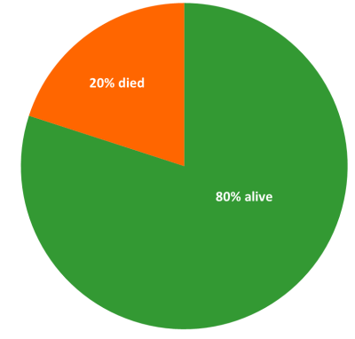 | pro: Black and white situation where you see at a glance “oh that’s it”. You do not have to think about it. (pt 2, f1)  con: I only see ‘’died’’. Deceased and gone.  (pt 1, f5)
2nd bar chart  (62 points) | 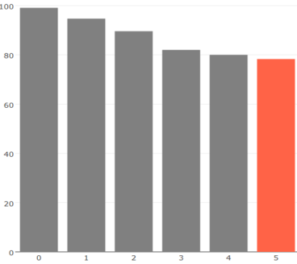 | pro: -  con: I don’t like it. (pt 4, f1)
3rd 100-person diagram  (58 points) | 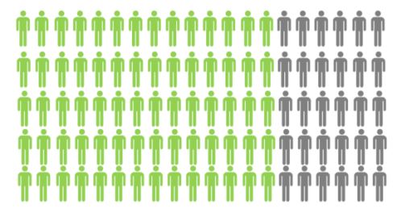 | pro: It is clear at a glance. (pt 2, f4)  con: Too confronting. (pt 4, f5)  These are just like people. (pt 3, f5)
4th survival graph (56 points) | 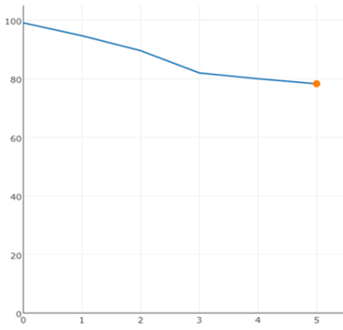 | pro: The graph is less harsh. I think it’s the nicest and most positive one. (caregiver 2, f5)  con: You always have a X-axis and Y-axis that you first need to interpret. (pt 6, f1) I find it too mathematical. (pt 2, f4)
5th 100- square chart (48 points) |  | pro: -  con: I don’t like it at all (several patients).
*First choice nomination resulted in five points, last choice nomination in one point. In total 315 points were divided. Figure 2 until 5 also included captions with the ‘% died’ versus ‘% survive’, and if applicable captions of the x- and y-axis (not shown in this table).

